ภาคผนวก ข.

รายละเอียดอุปกรณ์

ข.1 รายละเอียดของบอร์ดประมวลผล Vortex86-6071

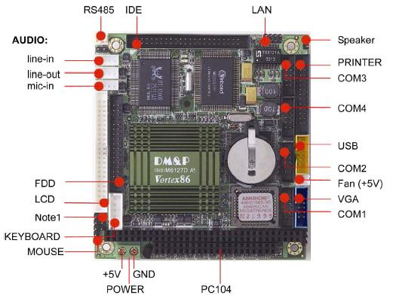

รูปที่ ข.1 บอร์ดประมวลผล Vortex86-6071

Processor Chipset DM&P(SiS)Vortex86 . System-on-Chip CPU–200MHz
Real Time Clock with Lithium Battery Backup
Bus Interface ISA and PC/104 Standard Compliant
Memory Onboard 128MB SDRAM (optional 128MB)
BIOS AMI BIOS
Multi I/O Enhanced IDE interface
RS232 port x3
RS232/485 port x1
Parallel port x1
FDD interface x1
USB port x1
Line-in port x1
Line-out port x1
Mic-in port x1
Video Display AGP Rev.2.0 Compliant
Shared system memory area up to 16MB.
Resolution up to 1,920Cx 1,440 true colors
CRT/LCD display
LAN Realtek 8100B single chip
Full-duplex transfer mode, doubles effective
bandwidth 16KB RAM buffer
Throughput 10/100Mbps
Connectors 2.0mm 44-pin box header for IDE
2.0mm 10-pin box header for RS-232 x3
2 pin header for RS-485
2.0mm 26-pin box header for Printer
2.0mm 34-pin box header for FDD
2.0mm 10-pin box header for USB
2.0mm 10-pin box header for VGA
2.0mm 8-pin header for Ethernet
2.0mm 44-pin box header for LCD connector
2.0mm 4-pin header for Line-in
2.0mm 4-pin header for Line-out
2.0mm 4-pin header for Mic-in
5-pin box header for AT-Keyboard connector
5-pin header for PS/2 Mouse
Watchdog Timer Software Watchdog Timer
Three 8254 Compatible Programmable 16-bit
Counters.
Power Requirement Single Voltage +5V @1.2 A
Board Weight 100g
Board Size 90mm X 96mm
Operating Temperature -20°C ~ +70°C
ข.2 รายละเอียดของอุปกรณ์วัดความเร่ง 3 แกน (3DM)

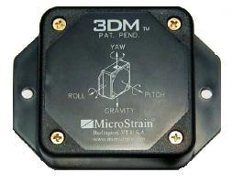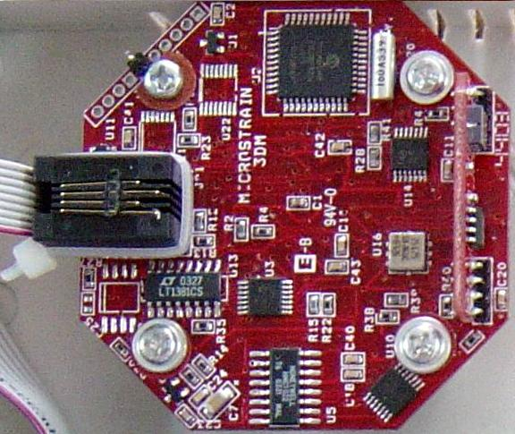

รูปที่ ข.2 อุปกรณ์วัดความเร่ง 3 แกน (3DM)

Range Yaw: ± 180 degrees
Pitch: ± 180 degrees
Roll: ± 70 degrees
A/D Resolution 12 bits
Digital Filter Infinite Impulse Response (IIR) User programmable weighted moving average
Angle Resolution (no digital filtering) Pitch: 0.30 degrees (typical)
Roll: 0.25 degrees (typical)
Yaw: 0.50 degree (typical)
Angle Resolution (most aggressive Pitch: < 0.1 degrees
digital filtering) Roll: < 0.1 degrees
Yaw: < 0.1 degrees

Resolution specs. taken during static motions.
Accuracy Pitch: ±0.93 degree typical (yaw from
0 - 360 degrees & roll=0 degrees)
Roll: ±0.33 degree typical (yaw from
0 - 360 degrees & pitch =0 degrees)
Yaw: ±1.0 degrees typical (pitch &
roll=0 degrees)

Accuracy is defined as the square root of the sum of the errors squared (non repeatability, temperature coefficients & non-linearity).
Angle measurement non-linearity ±0.23% F.S.
(pitch & roll)
Angle measurement repeatability Pitch: 0.07 degrees (typical)
Roll: 0.07 degrees (typical)
Yaw: 0.26 degrees (typical)
Update rate (angle mode) 45 Hz/ 3 channels (maximum)
30 Hz/ 3 channels (typical)

The update rate is specified with a maximum and typical value since it depends on how many points the A/D converter averages.
Update rate (raw mode) 70 Hz/ 6 channels
Output modes Raw: ax, ay, az accelerometer
Raw: mx, my, mz magnetic field
Units: pitch, roll, & yaw in degrees
Output format RS-232 serial or RS-485 multi-drop network
Transmission Rate 9600 bits/sec
Supply voltage 5.3 volts DC min
Supply current 50 milliamps/node @ standard speed
Connectors Sensor: RJ11 type power: min. coaxial jack
Operating Temperature - 25 degrees C to 70 degrees C
Temperature Drift (%/ deg. C) Pitch: 0.009+/-0.008
(mean, std.dev.) Roll: 0.033+/-0.025
Yaw: 0.019+/-0.019
Module size 1.7" wide, 2.5" long, 0.7 " thick
3DM enclosure 2.05" wide x 3.815" long x 0.9" thick
ข.3 รายละเอียดของ GPS Receiver (Holux รุ่น GM-82)

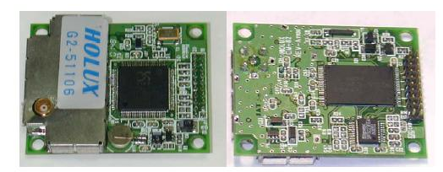

รูปที่ ข.3 GPS Receiver (Holux รุ่น GM-82)

- SiRF Star II chipset with embedded ARM7TDMI CPU available for customized applications in firmware
- 12 parallel satellite-tracking channels for fast acquisition and reacquisition
- High speed signal acquisition using 1920 time/frequency search channels
- Use Frequency 1575.42 MHz
- Built-in WAAS/EGNOS Demodulator
- Support U.S. Coast Guard DGPS beacon signal
- Low power consumption with Advanced Trickle-Power and Push-To-Fix mode
- Optional Rechargeable battery for memory and RTC backup and for fast Time to First Fix(TTFF)
- Support NMEA0183 v2.2 data protocol and SiRF binary code
- Enhanced algorithms -SnapLock and SnapStart provide superior navigation performance inurban, canyon and foliage environments
- For Car Navigation , Marine Navigation ,Fleet Management ,AVL and Location-Based Services ,Auto Pilot ,Personal Navigation or touring devices, Tracking devices/systems and Mapping devices application.
- Input voltage: 5.0Vdc +/-10% or 3.3Vdc +/- 10%
- Backup power:(optional)。3V Rechargeable Lithium cell battery, up to 1000 hours discharge.
- MCX antenna connector: Active or patch.
- PCB Size: 40(W) x 50(D) x 12(H) (mm)
- Weight: 18 g
Performance
- Update rate: 1 second.
- Acquisition time:
- Reacquisition 0.1 sec, averaged
- Hot start 8 sec. averaged
- Warm start 38 sec. averaged
- Cold start 45 sec. averaged
- Position accuracy:
Non DGPS (Differential GPS)
- Position 5~25 meter CEP
- Velocity 0.1 meters/second.
- Time 1 microsecond synchronized GPS time
DGPS (Differential GPS)
- Position 1 to 5 meters, typical
- Velocity 0.05 meters/second, typical
EGNOS/WAAS
- Position < 2.2 meters, horizontal 95% of time
< 5 meters, vertical 95% of time

